**Robert McDonell**

**WDV 151**

[**Find sites that display line, shape and volume.**](https://dmacc.blackboard.com/webapps/assignment/uploadAssignment?content_id=_2807685_1&course_id=_56847_1&group_id=&mode=view)

Find four different sites that utilize:

**Line** - to separate elements or as a design element

[www.acko.net](http://www.acko.net)

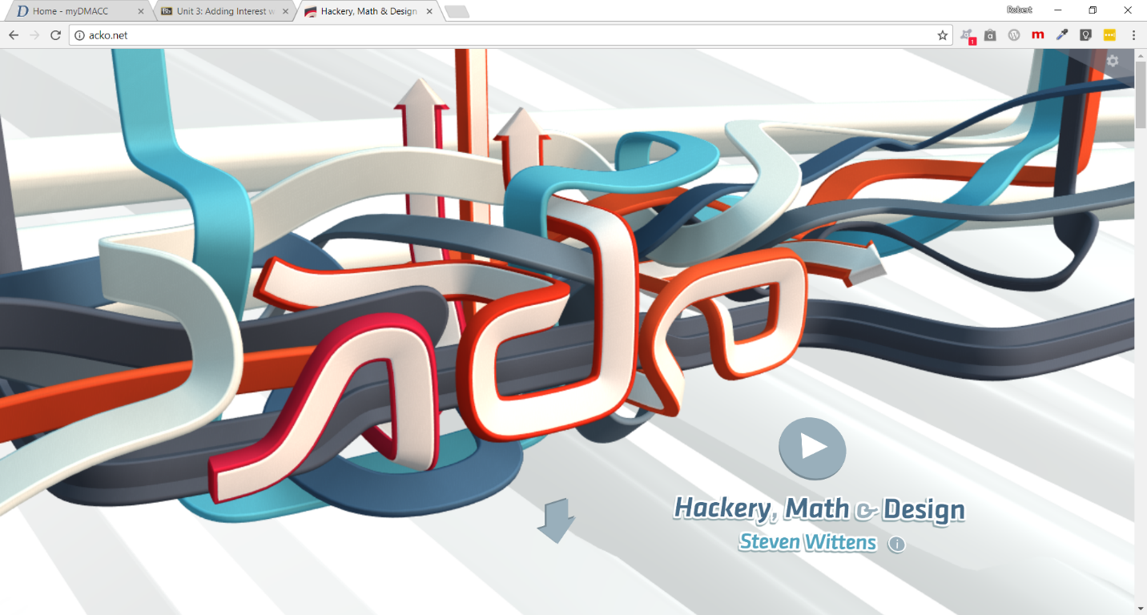

**Shape** - in the form of rounded corners, circles, or rotation.

https://www.mq.edu.au/sustainability/greencampusguide/

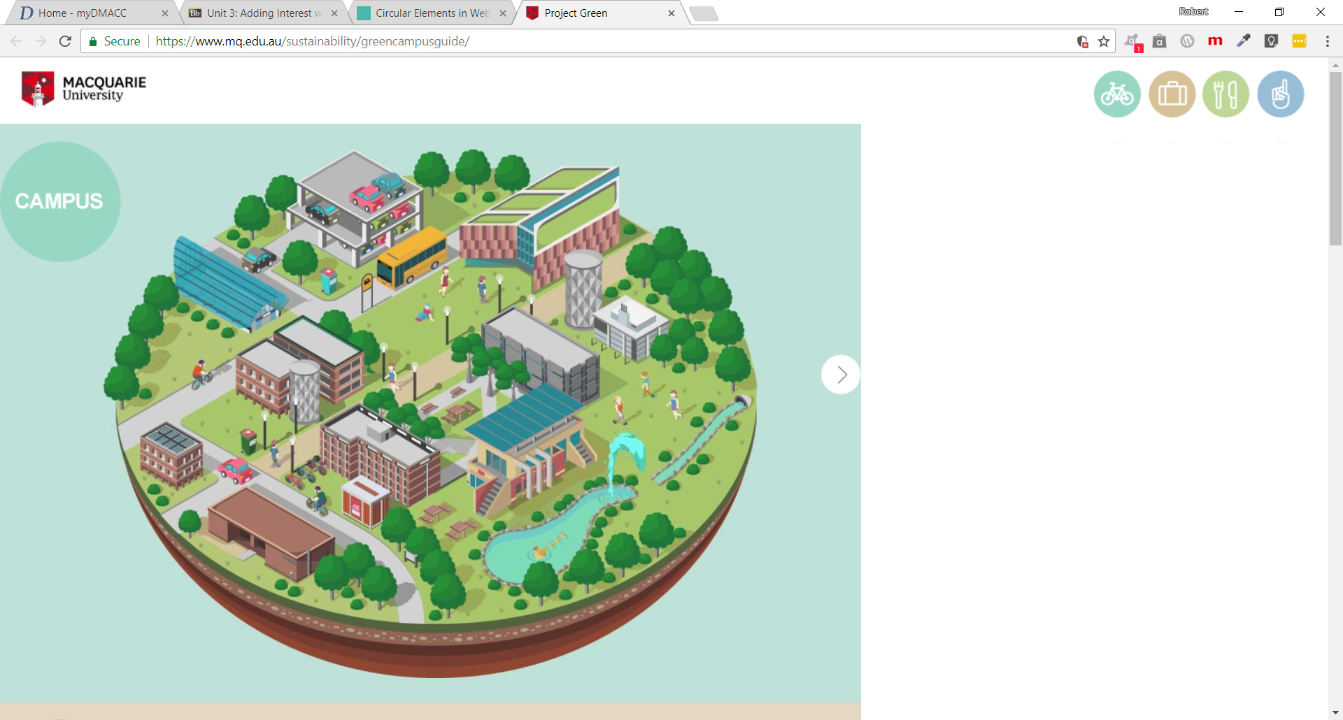

**Depth and Dimension** - use of drop shadows, gradient and/or transparency.

Depth:

<http://www.mrsaghafi.com/#/works>

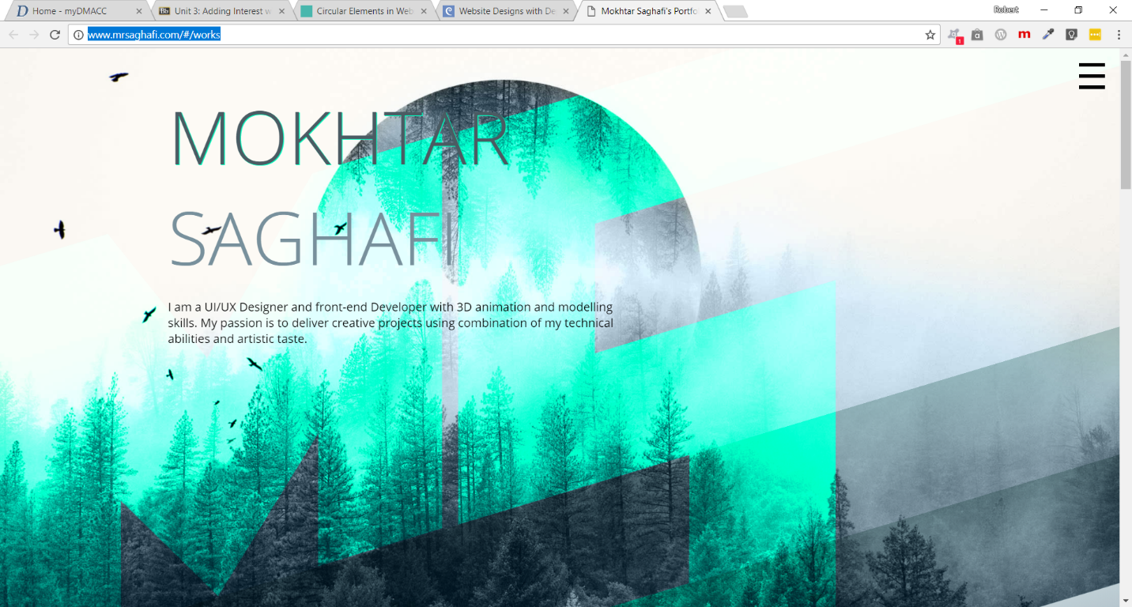

Dimension:

<http://www.thewizad.com/>

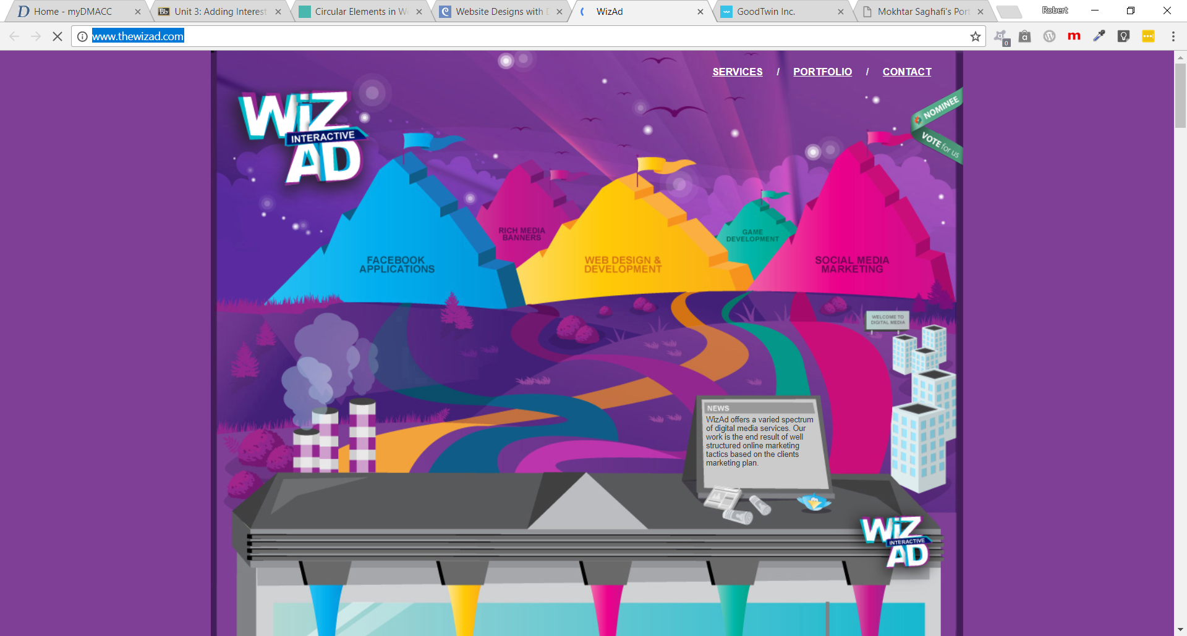

You may find a site that uses all three, or a combination. Still - find four different sites.